Name – Rohit Ranjan Reg No – 22MCA10071

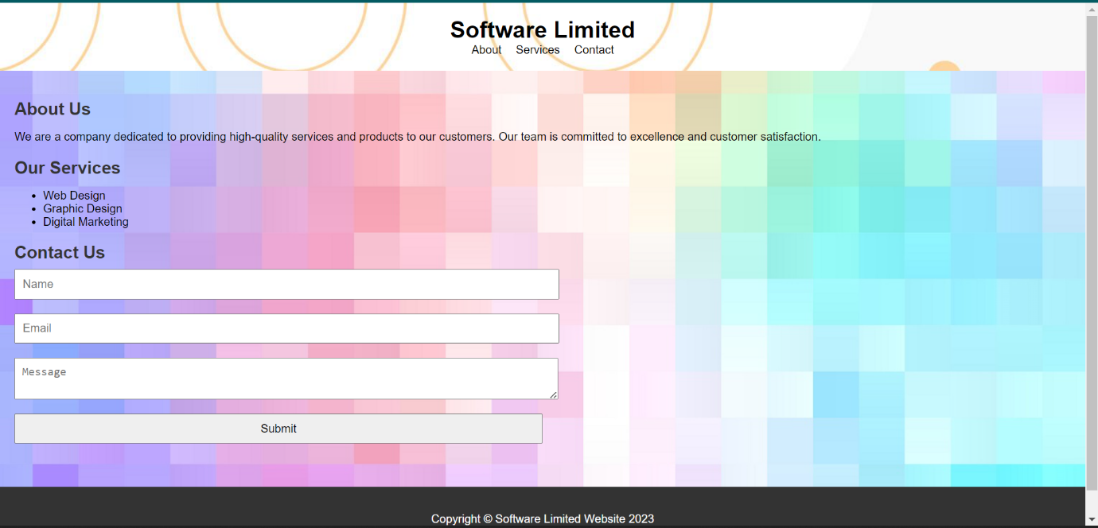

HTML Code:-

<!DOCTYPE html>

<html>

<head>

  <title>Software limited</title>

  <link rel="stylesheet" type="text/css" href="web1style.css">

</head>

<body>

  <header>

    <h1>Software Limited</h1>

    <nav>

      <ul>

        <li><a href="#about">About</a></li>

        <li><a href="#services">Services</a></li>

        <li><a href="#contact">Contact</a></li>

      </ul>

    </nav>

  </header>

  <main>

    <section id="about">

      <h2>About Us</h2>

      <p>We are a company dedicated to providing high-quality services and products to our customers. Our team is committed to excellence and customer satisfaction.</p>

    </section>

    <section id="services">

      <h2>Our Services</h2>

      <ul>

        <li>Web Design</li>

        <li>Graphic Design</li>

        <li>Digital Marketing</li>

      </ul>

    </section>

    <section id="contact">

      <h2>Contact Us</h2>

      <form>

        <input type="text" placeholder="Name">

        <input type="email" placeholder="Email">

        <textarea placeholder="Message"></textarea>

        <input type="submit" value="Submit">

      </form>

    </section>

  </main>

  <footer>

    <p>Copyright &copy; Software Limited Website 2023</p>

  </footer>

</body>

</html>

CSS Code –

body {

  font-family: Arial, sans-serif;

  background-image: url("background1.jpg");

  margin: 0;

  padding: 0;

}

header {

    background-image: url("back3.jpg");

  /\* background-color: #333; \*/

  color: rgb(0, 0, 0);

  padding: 20px;

}

header h1 {

  margin: 0;

  text-align: center;

}

nav ul {

  list-style: none;

  margin: 0;

  padding: 0;

  display: flex;

  justify-content: center;

}

nav li {

  margin: 0 10px;

}

nav a {

  color: rgb(0, 0, 0);

  text-decoration: none;

}

main {

  padding: 20px;

}

section {

  margin-bottom: 20px;

}

section h2 {

  color: #333;

  align-self: center;

  margin-bottom: 10px;

}

footer {

  background-color: #333;

  color: #fff;

  padding: 20px;

  text-align: center;

}

form {

  display: flex;

  flex-direction: column;

  align-items: flex-start;

}

form input, textarea {

  width: 50%;

  padding: 10px;

  margin-bottom: 20px;

  font-size: 16px

}